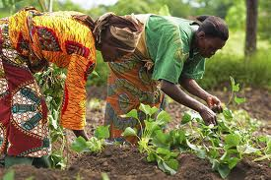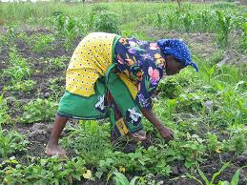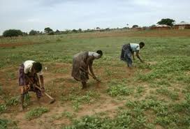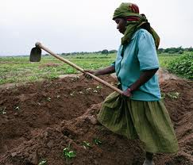

* **The men that work in Tanzania as farmers or agricultural workers.**
* **This profession was made up of 100% men and all of the women stayed at home making sure that food is cooked and their house is kept properly.**

Against What?

* Tanzanian Women

Through Tanzanian Women

How Tanzania Took A Stand

# Who?

Agriculture and farming is now a fairly 'feminized' line of work and more than 80% of rural women are farmers or are in another type of agriculture work. Also, the Tanzanian government along with UN women and the UN capital Development Fund (UNCDF) passed the Gender Equitable Local Development (GELD) which states that their must be gender-responsive budgeting. This means that women have to have as much being spent to get them resources as the men. Also, they were given a say in the decision making that would effect their daily lives, a luxury they were not granted before.

# What was the result?

**They started working as farmers to show the men that women can do anything that a man can do and that they are meant for more than making sure the house is kept tidy all of the time. They also started working in other areas of work, but agriculture and farming was the main profession because a lot of the women lived in rural areas and farming was the most physically demanding job they could find that would show the male population that women were strong and can do the hard work that men do.**

# What did they do?