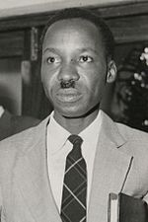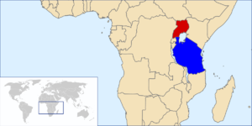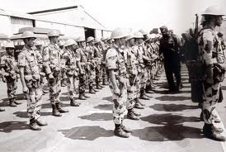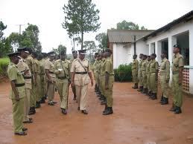

Julius Nyerere

* Julius Nyerere and the Tanzanian Army

# Who?

**Against What?**

* Idi Amin, the leader of Uganda, and his troops, which included thousands from the leader of Libya, Muammar Gaddafi.

Through the Uganda-Tanzania War

How Tanzania took a Stand

The Tanzanians were able to fix the Ugandan government by helping the exiled Ugandans take away Idi Amin.  They made the right decision in helping another country stand up fir themselves to take down Amin.

# What was the result?

retreating. Tanzanians and the exiled Ugandans kept invading other cities and after overcoming the Entebbe airfield and taking down Kampala Tanzanian troops stayed in Uganda to help maintain peace while the Ugandans helped to elect a new government.

**What did they do?**

The Tanzanians chose to stand up for the Ugandans to help overthrow the leader, Idi Amin when he first gained power in 1971, and Tanzania kindly offered the ousted president, Milton Obote and 20,000 refugees fleeing from Amin plus more exiles sanctuary. Additionally, in late 1978, after Amin escaped in a helicopter after Tanzanian’s attempt of ambush Amin's vice president, Mustafa Adrisi, was injured in a car accident making his loyal troops fight back against Amin who successfully fled into Tanzania, and in revenge, Amin attempted to conquer part of the Kagera region, a place in northwestern Tanzania. However, Julius Nyerere brought together a defense troops to counter-attack.  With an original amount of 40,000 Tanzania’s troops increased to over 100,000. Using a Russian rocket launcher aiming at Uganda, The Tanzanian Army made the Ugandan Army retreat slowly. Unfortunately for the Tanzanians, Muammar Gaddafi sent 2,500 troops to aid Amin, all equipped with amour and weapons. Despite that, Amin used the Libyan troops to fight while the Ugandan Army stole Libyan's equipment. Tanzanian Troops attempted to made north all the way to the capital city of Uganda, however, but stopped north at Lukaya, a city in Central Uganda, at a swamp. The plan was to send two Brigades: One was to be sent directly across the causeway of the swamp. The other was a backup in case the causeway was blocked or damaged. The Tanzanians forces collided with the Libyan forces heading to Masaka resulting in disorganization. Despite that, the Tanzanian Army counter-attacked attacked shortly after from two different directions, which succeeded leaving Libyan troops